SCOPED APPLICATION INSTALLATION AND CONFIGURATION GUIDE
Genesys Cloud Connector

Table of Contents
1. Overview 3
2. Application Dependencies 3
3. Configuration Instructions 4
3.1. Configuring Genesys Cloud Connector in ServiceNow 4
3.2 Authorize ServiceNow connector’s OAuth Client in Genesys Cloud 14
3.3 Configuring Agent access to ServiceNow connector in Genesys Cloud 15
3.4 Multiple OpenFrame 16
4. Support and Troubleshooting 17
4.1 Service Level Agreement Definition 17
4.2 Troubleshooting 17

- Overview
Overview
Genesys Cloud Connector enables seamless integration between Genesys Cloud and the ServiceNow platform, offering several key features such as a Genesys Cloud widget in ServiceNow, contact search, automated interaction, incident and case creation with screen pops, bi-directional data exchange, and click-to-dial functionality. This integration streamlines workflow, enhances customer service, and boosts productivity by bringing together the capabilities of both platforms within a unified environment.
This document outlines the step-by-step process for setting up the Genesys Cloud Connector, empowering users to effectively leverage its capabilities.

- Application Dependencies
- List all plugins required:
  - Open Frame Plugin
  - Plugins to support CSM features (i.e. enableIxnCreation, enableCaseCreation)
    - Customer Service
    - Interactions Management
  - Plugins to support HRSD features (i.e. enableHRCaseLookup)
    - HR Agent Workspace
- List all system table permissions required: incident, customer_contact, sn_customerservice_case, interaction

- Configuration Instructions
  - Configuring Genesys Cloud Connector in ServiceNow
In this section, we will detail the exact steps necessary to successfully install and configure the customer's instance following the installation of Genesys Cloud Connector from ServiceNow.
- Following the installation, verify whether the application has been successfully installed.
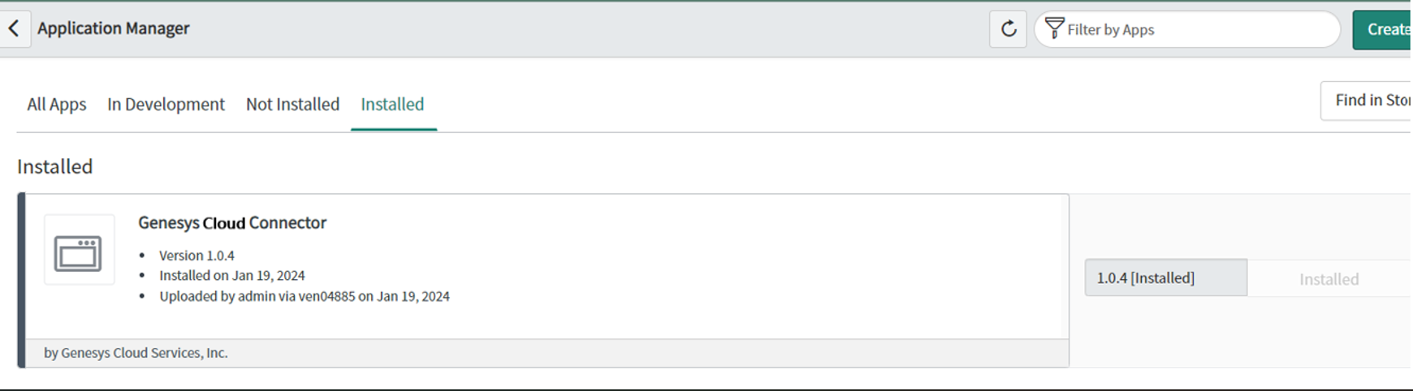
- Navigate to the Genesys Cloud Connector.
  - You will notice a warning icon. Toggle the switch to activate the Genesys Cloud Connector.
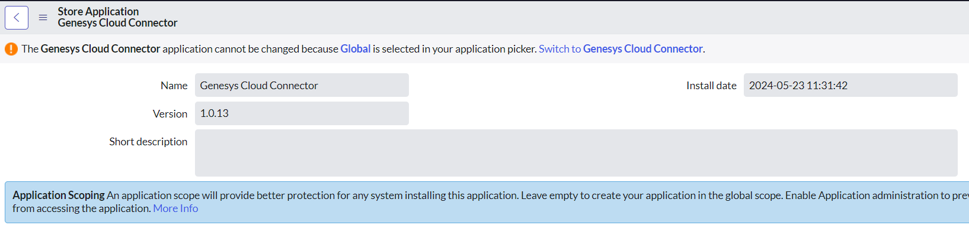
- Verify the creation of the following files:
  - Use the Filter Navigator to search for "OpenFrame".
  - Check if the "Genesys ServiceNow Connector" file has been created.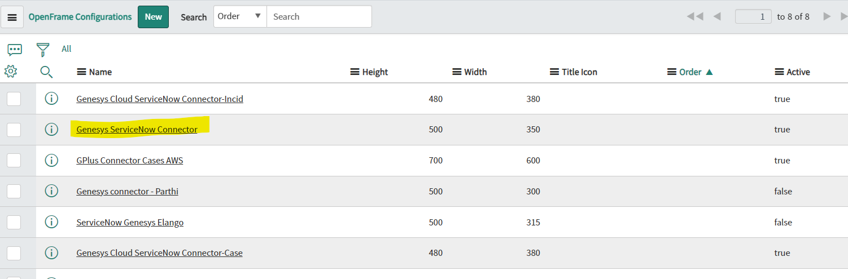
  - Ensure that the auto-created group assigned to that file is checked. Group Name: "Genesys Integration Permissions".
- Navigate to "System Definition" in the Filter Navigator and select "Script Include".
  - Verify whether the "genesys_connector_snow" file has been created.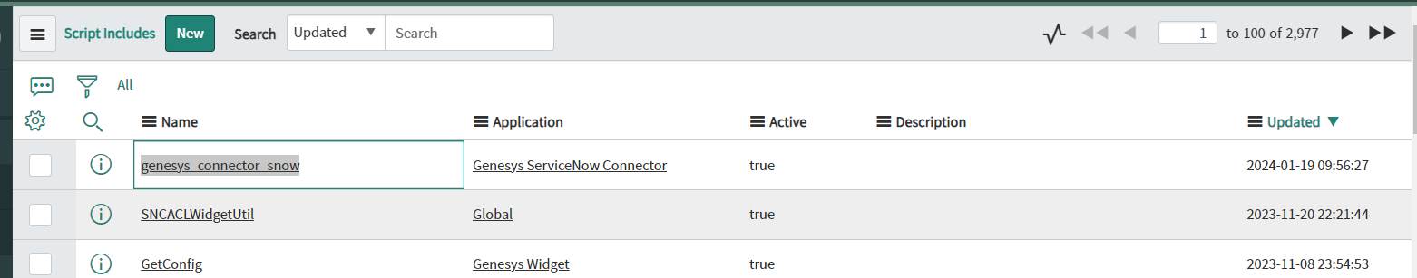
- Use the Filter Navigator to search for "UI Page" and click on it.
  - Verify the creation of the "genesys_integration_widget" file.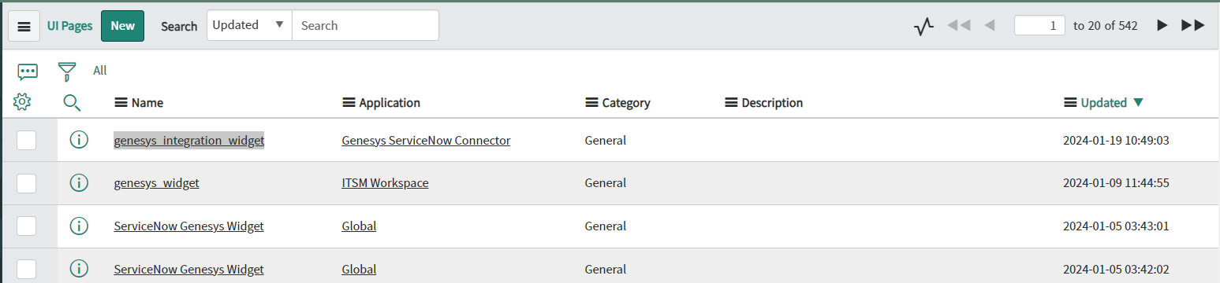
  - Verify the creation of the "genesys_help_guide" file. 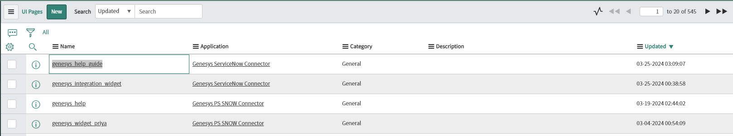
- Refresh the page and search for "Genesys Cloud Connector" in the Filter Navigator. You will find the necessary tab displayed in the navigator.
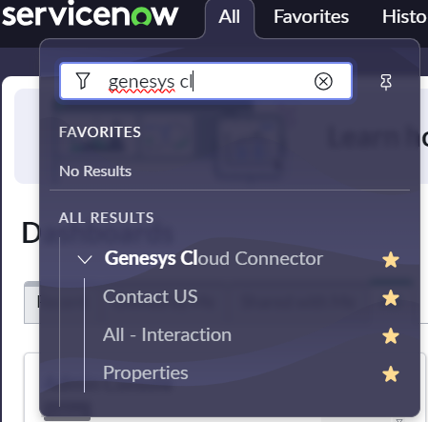
- Navigate to "User Administration" in the Filter Navigator and select "Groups".
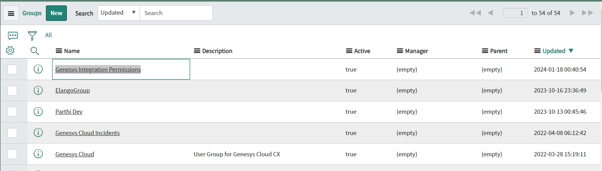
  - Click on it. Within the tab, you'll find the "Group Members" section. Edit and assign the necessary members to manage the Genesys Connector. Update the changes and refresh the page.
  - You'll notice the Phone icon and Genesys Connector in the top right corner of the application.While login into the Genesys Connector, the widget will be visible.
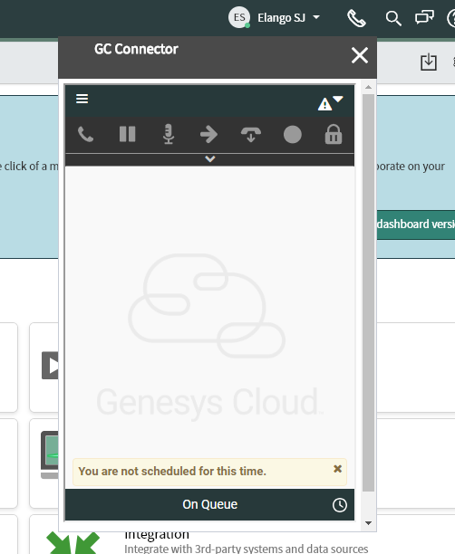
- Modify the Connector properties to align with the screen pop and task automation requirements.
Properties | Details
Enable either Incident Creation, Case Interaction, IXN Creation or HR Case Lookup.  Property name: enableTypeOfCreation | Select any one option from the drop down list,  - enableIxnCreation  - enableCaseCreation  - enableIncidentCreation  - enableHRCaseLookup  enableIxnCreation: When this option is selected, connector creates a new ServiceNow interaction for every Genesys interaction answered.  enableCaseCreation: When this option is selected, connector screenpops the list of open cases associated with the identified contact, along with the ability to create a new case.  enableIncidentCreation: When this option is selected, connector screenpops the list of associated incidents for the identified user, along with the ability to create a new incident.  enableHRCaseLookup: When this option is selected, connector screenpops the list of associated HR Case for the identified user, along with the ability to create a new interaction.  Enabling scope for HR Workspace:  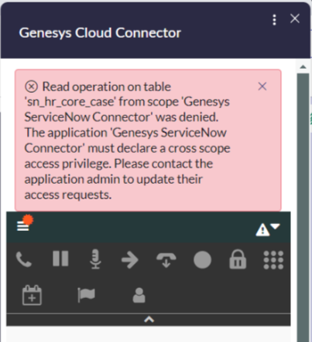  Follow below steps to define scope for HR work space within “Genesys Cloud Connector”  - Go to -> Restricted Caller Access Privileges -> search for Scope application (“Genesys Cloud Connector”).  - Set the status to allowed for read and write operation.  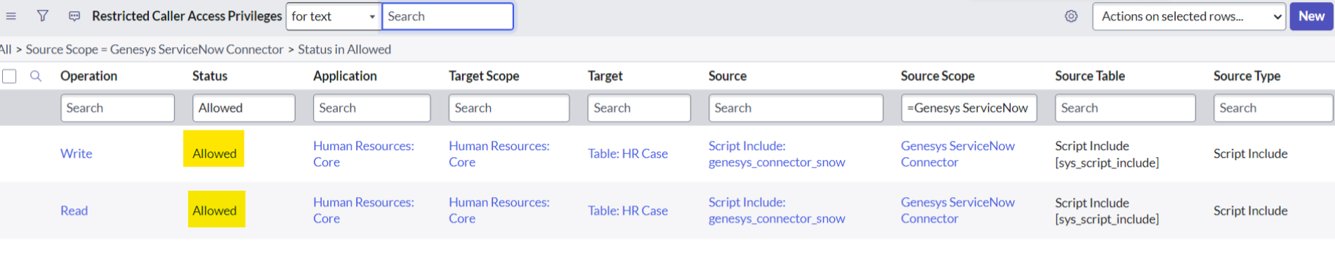
Auto close the ServiceNow interaction on Genesys IXN disconnect after the selection of the wrap-up code in the Genesys widget. (Applicable only if enableIxnCreation is selected)  Property name: autoCloseIxnOnDisconnect | If this option is enabled, then auto created interaction record will be closed as soon as the wrap-up code is submitted on Genesys Cloud widget.  By default, this option is set to false.  No: This option works only if the enableIxnCreation feature is enabled.
Custom Search criteria  Property name: enableCustomSearch | Enable Custom Search criteria with the following JSON structure:  {  "voiceCustomSearch": {SN_Field_Name_1: Genesys participant key1},  "emailCustomSearch": {SN_Field_Name_2: Genesys participant key2},  "chatCustomSearch": {SN_Field_Name_3: Genesys participant key3}  }  You can enable all, some, or just one of these options. Include only the keys you want to enable; leave the others blank.  This property acts as a hashmap, mapping sn_key to interaction_key. The sn_key is used to query from the user table, while the interaction_key is the participant data key set in Genensys call flow during the call.
Field Mapping for Auto creation of Records / can include mapping for wrapup code/call duration update on disconnect. (Optional)  Property name: interaction_key | - Map participant data to ServiceNow fields  With the help of this option, participant data can be mapped in the fields of servicenow records on auto record creation.  Format:  {SN_Field_Name_1: Genesys participant key1, SN_Field_Name_2: Genesys participant key2,…}  - Map Interaction meta data to servicenow fields:  Interaction meta data such as id, type, queue name etc can also be mapped in the fields of servicenow records on auto record creation. Some meta data are available only after disconnect, some are available on answer itself.  Format:  {SN_Field_Name_3: Ixn_Meta_Data_name1, SN_Field_Name_4: Ixn_Meta_Data_name2,…}  Ex:  {“ snfield_1”: “participantKey1”,”snfield_2”:”ixn.queue”,”sn_field_3”:”ixn.call_duration”}
  Meta data Key Name | Description
  ixn.id | ID of the Genesys Interaction
  ixn.queue | Queue name
  ixn.direction | Direction of the Genesys Ixn  Possible values: Inbound/Outbound
  ixn.link | Genesys Ixn details page link
  ixn.ani | Caller ANI of incoming Genesys voice interaction
  ixn.type | Type of Genesys interaction  Possible values:  Call, Chat, Email
  ixn.dnis | DNIS of Genesys Ixn
  Ixn.start_time | Start time of Genesys Ixn
  ixn.wrapup_code | Wrapup code submitted on Genesys cloud widget. This interaction meta data will be available only after disconnect and wrapup selection in Genesys Cloud widget.
  ixn.call_duration | Duration of the voice call. This interaction meta data will be available only after disconnect and wrapup selection in Genesys Cloud widget.
  Ixn.end_time | End time of Genesys Ixn.  This interaction meta data will be available only after disconnect and wrapup selection in Genesys Cloud widget.
Field mapping to update Servicenow fields on transfer (Optional)  Property name: updateOnTransfer | With this option, Genesys participant data and Interaction meta data (ixn.id, ixn.queue, ixn.direction, ixn.link, ixn.ani, ixn.type, ixn.dnis) can be mapped to ServiceNow field of auto created or selected Interaction/incident/case record, when the transferred interaction is accepted by Agent2.  The below interaction meta data is available only on transfer scenario.  Format:  {SN_Field_Name_1: Genesys participant key1, SN_Field_Name_2: Genesys Interaction meta data2,…}  Ex:  {“ snfield_1”: “participantKey1”,”snfield_2”:”ixn.transfer_type” }
  ixn.transfer_type | Type of transfer.  Possible values:  blindTransfer, consultTransfer
Select the ServiceNow phone field to search records for voice interactions  Property name: voiceSearchField | Select any one option from the drop down list,  - Business Phone  - Mobile Phone  - All Phone Fields  Business Phone: If this option is selected, the search will be done on the business phone field of service now Contacts/Users for incoming/outgoing voice interactions.  Mobile Phone: If this option is selected, the search will be done on the Mobile phone field of service now Contacts/Users for incoming/outgoing voice interactions.  All Phone Fields: If this option is selected, the search will be done on Business Phone, Mobile phone and home phone fields of service noe Contacts/Users for incoming/outgoing voice interactions.
List of tables used for Direct screenpop feature  Property name: customEntitiesList | Specify additional ServiceNow tables (beyond the default incident, interaction, and sn_customerservice_case tables) required for direct screen pop functionality. Multiple table names can be entered using comma separation.  Format:  ServiceNowTable1,ServiceNowTable2…  Ex:  sys_user,customTable1  Direct Screenpop feature:  To screenpop the servicenow record directly using participant data.  This feature requires three participant data.  'directscreenpop_table' – Servicenow table to lookup  'directscreenpop_field' – Coloumn name to lookup  'directscreenpop_value' – value  Ex:  'directscreenpop_table' – incident  'directscreenpop_field' – number  'directscreenpop_value' – INC0000976  For the above participant data values, connector will directly screenpop the incident record ‘INC0000976’, pass the incident record sysid to Genesys Interaction and update the Genesys IXN link to worknotes. On interaction end, it will update the wrapup message to the worknotes of that record.  If any of these participant data is missing, then it will fallback to the default search and screenpop of the selected feature (i.e) enableIxnCreation, enableCaseCreation etc.
Disable screenpop for outbound interaction  Property name: noScreenpopOnOutbound | If this property is enabled, the connector will not perform any search or screenpop an entity for Genesys outbound interactions.
Create phone logs for voice calls  Property name: enablePhoneLogCreation | If this property is enabled, the connector will create phone log record in servicenow for each Genesys voice interactions.
Enable external routing to Genesys Cloud  Property name: enableExternalRouting | If this property is enabled, Genesys External Routing will be enabled and initialized. ServiceNow work items will then use Genesys Cloud routing solution for work item assignment to agents.
Genesys Cloud Region  Property name: gcEnv | Genesys Cloud Org Region  Required.
Enable Genesys Cloud's Pop Authentication feature to enhance security and user verification.  Property name: enablePopupLogin | When this option is enabled, a popup window will be shown for GC widget login.  Allowed values:  “true” or “false”  Default:  “false”
Name of the organization.  Property name: orgname | Genesys Cloud Org name  Required - if SSO login is used in GC org
Specify the provider's name.  Property name: provider | SSO provider name  Required - if SSO login is used in GC org  Valid values:  "okta", "adfs", "salesforce", "onelogin", "gsuite", or "ping".
Acquiring the Genesys interaction link within the context.  Property name: genesysIxnLink | On accepting the interaction, Genesys Interaction link will get updated in work notes of corresponding auto created record (interaction/sn_customerservice_case/incident).  Interaction link is available in $link placeholder. Content is customizable.  Ex:  “Genesys Interaction Link: $link”  This is optional.
Following the interaction, The wrap-up code to conclude the interaction.  Property name: wrapupTemplate | On disconnecting the interaction, the wrapup code will get updated in work notes of corresponding auto created record (interaction/sn_customerservice_case/incident).  Wrapup info is available in $wrapUpCode placeholder. Content is customizable.  Ex:  “Genesys interaction is wrapped up with code: $wrapUpCode”  This is optional.
Show Wrap Up Notes  Property name: showWrapUpNotes | To enable ACW notes at the end of an interaction in Genesys connector set this value to Yes.  By default, this is set to No.
Properties configuration page | 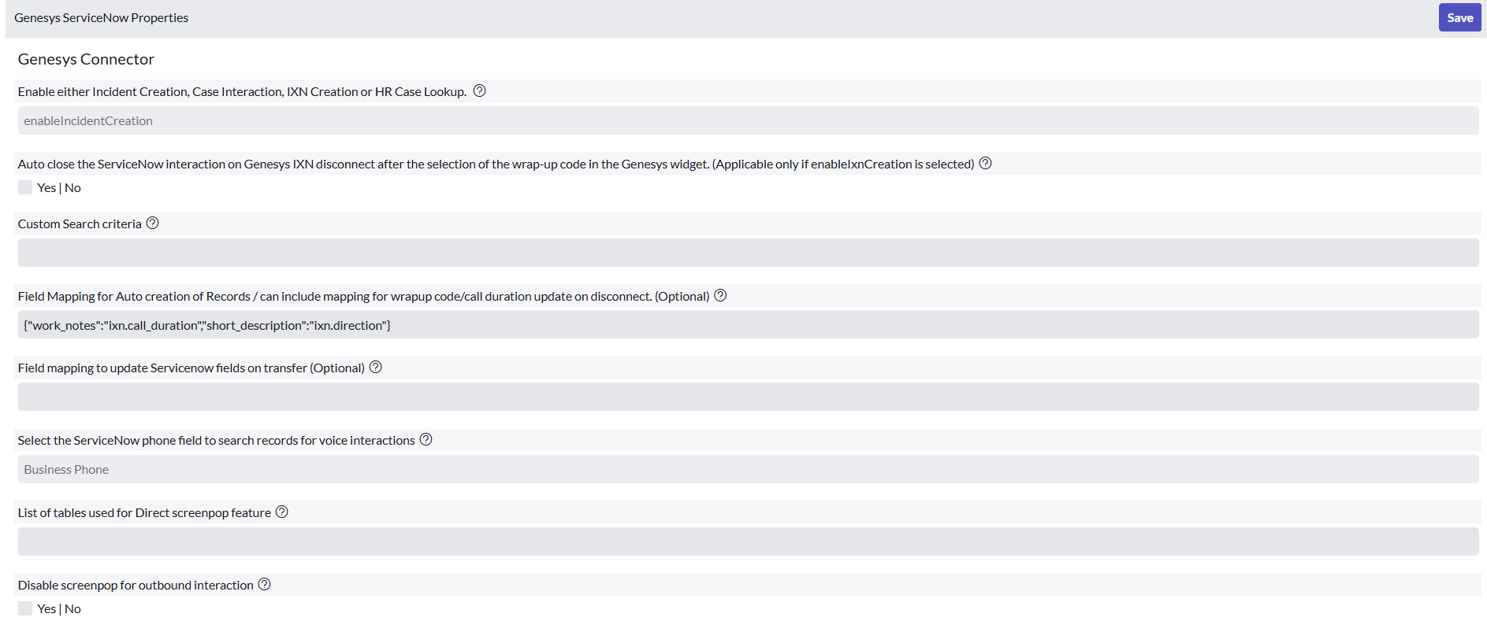  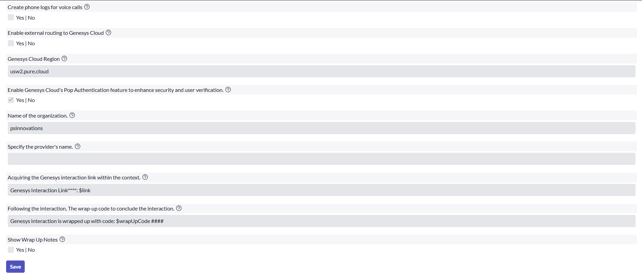

To access the Genesys Connector, the following roles are necessary for both groups and users.
- x_inics_gen_snow.genesys_sn_role
- sn_openframe_user

3.2 Authorize ServiceNow connector’s OAuth Client in Genesys Cloud
Please follow the steps below within Genesys Cloud org to approve connector’s OAuth client.
- Go to Admin -> Integrations -> Authorized Applications.
- Search for ‘Servicenow connector’ in App Name and select the record.
- Check all the scopes and click on Save.

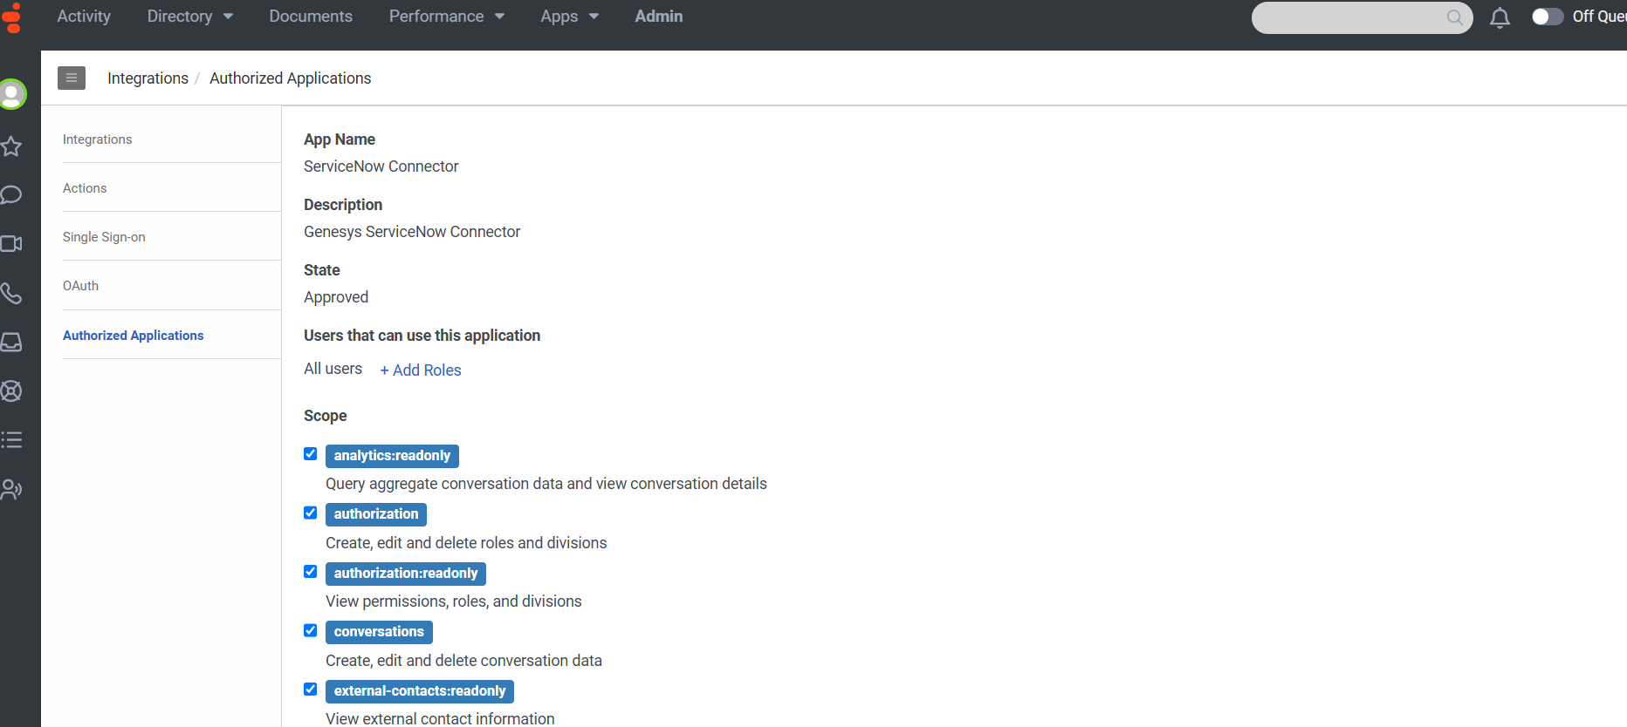

3.3 Configuring Agent access to ServiceNow connector in Genesys Cloud
Please follow the steps below within Genesys Cloud org to assign agents with permissions to access ServiceNow connector within ServiceNow,

- Grant the permission ‘genesysSNow’ to the users who need access to the connector.
  - Go to Genesys Cloud Org
  - Under admin, click ‘Roles/Permissions’
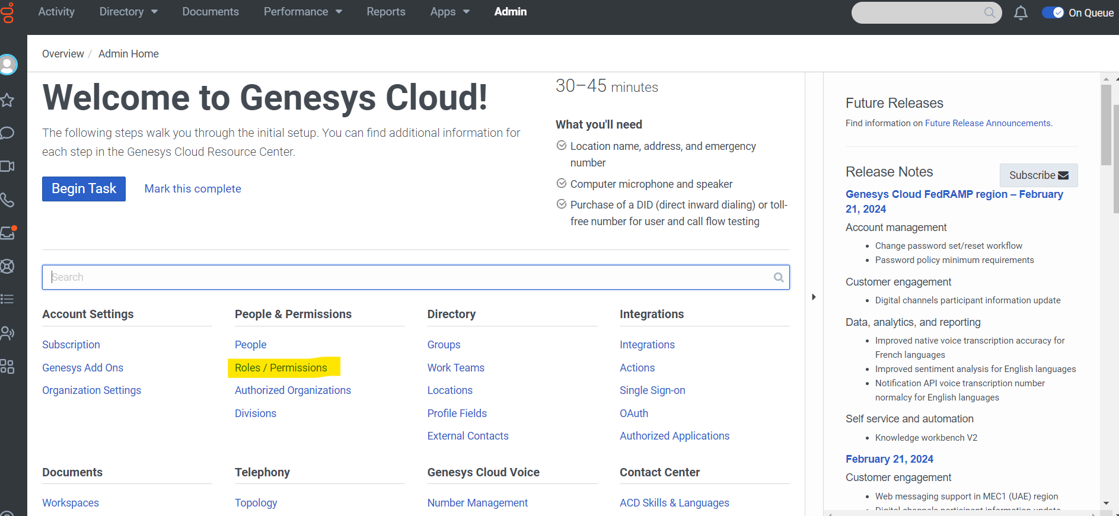

- You can create a new Role with the ‘genesysSNow’ permission and assign this role to the user or add this permission to the existing role.
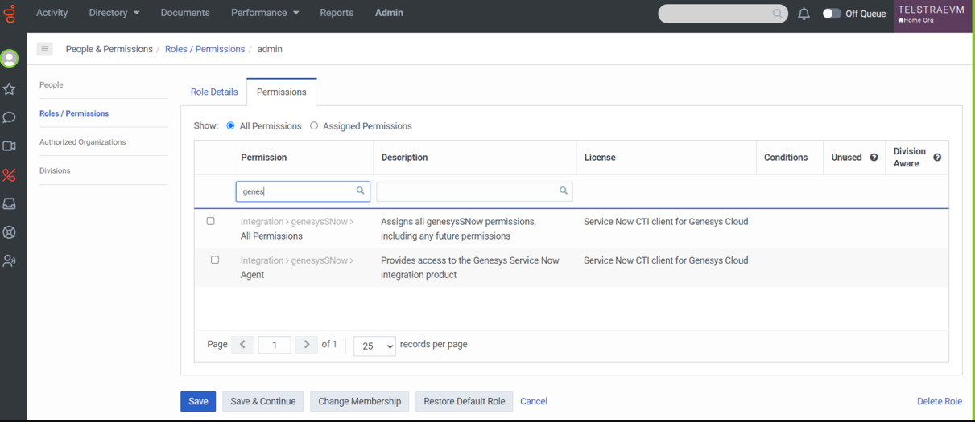

3.4 Multiple OpenFrame
Global Genesys Connector properties can be overridden by the active OpenFrame configuration assigned to each ServiceNow (SNOW) user. It is possible to have multiple OpenFrame configurations set as active.

A configuration input box is available on each openframe configuration where the properties to be overridden can be configured. And these overridden values will be applicable to the users who are all part of the user group selected in the User Group field of that corresponding openframe configuration entry.
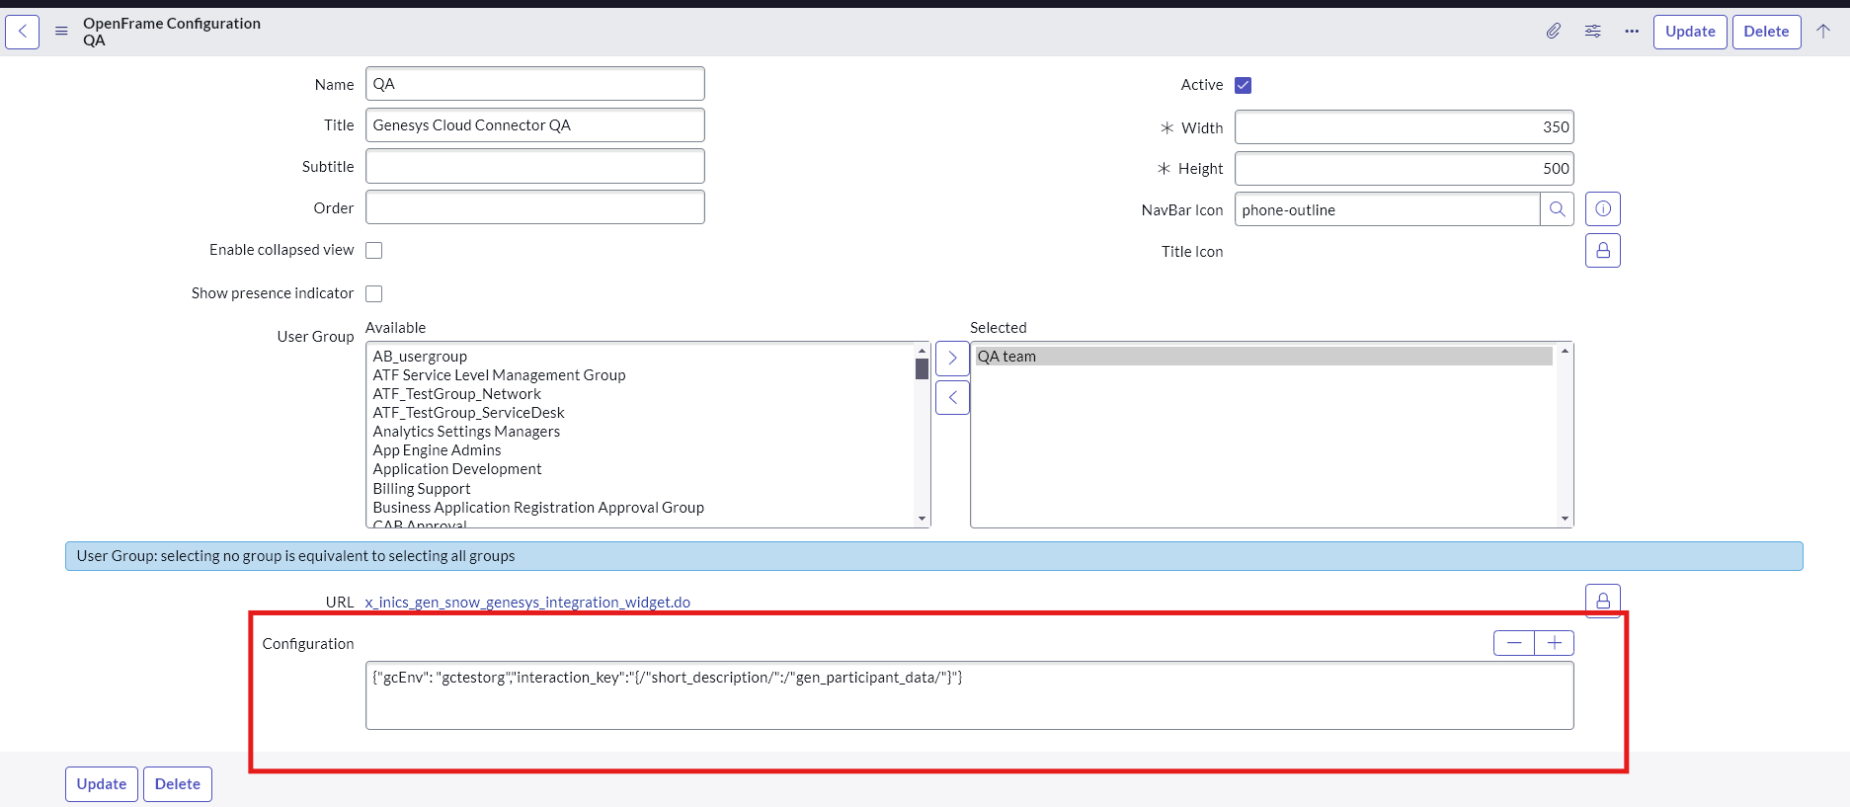

Syntax:
{<property_key_name1>:<value1>, <property_key_name2>:<value2>,…}

Ex:
{"gcEnv": "gctestorg","interaction_key":"{/"short_description/":/"gen_participant_data/"}"}

- Property names can be taken from Global property page by hovering over the question mark.
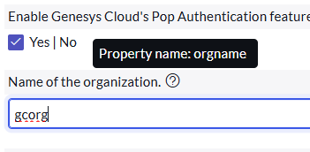
- Property name and value needs to be enclosed with in double quotes. If the value of the property is expected as a json string, then the double quotes inside the json string should be escaped by back slash (\).
For Ex, interaction_key property accepts only json. The value is expected as json string as mentioned in the above example.

- Support and Troubleshooting
Custom Application Support service is provided by Genesys Professional Services in concert with the Customer Care organization as a seamless process managed through a single point of contact, the Customer Care support interface, and offered through a variety of channels including phone, email, and web.
ServiceNow Connector Support Guide

4.1 Service Level Agreement Definition
Custom Application Support process and SLA’s are defined here.

  - Troubleshooting
- In case of configuration issues, error messages will be displayed in browser logs, providing relevant information to correct configuration values. When submitting a case with Genesys, please ensure to share browser and console logs for further investigation.
- To troubleshoot the embeddable widget, refer to the troubleshooting guide available at: https://help.mypurecloud.com/articles/troubleshoot-the-genesys-cloud-embedded-clients/

End of Document

